**Chapter One  
Online Reading Volunteers**

Volunteers’ Week 2024 Toolkit for our  
online reading volunteers

**Volunteers’ Week 2024  
Monday 3 June to Sunday 9 June**

[**Volunteers' Week**](https://volunteersweek.org/)celebrates the amazing contributions volunteers make to communities across the UK. Starting on the first Monday in June every year, it’s **a chance to recognise and thank** the UK’s incredible volunteers - and at Chapter One we will most certainly be shouting our appreciation for our online reading volunteers very loudly from the rooftops!

#### This year is the 40th anniversary of Volunteers’ Week and there are a number of ways in which you can join in by celebrating being a Chapter One online reading volunteer - and the vital role you play in helping to close the reading gap in the UK**.**

**How can you get involved as a valued Chapter One online reading volunteer?**

**We would love it if you post on social media about why you’re proud to volunteer for Chapter One!**

### **Don't forget to tag us!** Please include our handles (on X/Twitter and Instagram) or tag us (on LinkedIn and Facebook) in your posts to make it easier for us to share and amplify them. Please also make sure you are following us!

**LinkedIn:** [**chapteroneuk**](https://www.linkedin.com/company/chapteroneuk) **X:** [**@chapterone_uk**](https://twitter.com/chapterone_uk) **Instagram:** [**@chapterone_uk**](https://www.instagram.com/chapterone_uk/) **Facebook:** [**ukchapterone**](https://www.facebook.com/ukchapterone)

**If you are able to record a short video testimonial (e.g. a one-minute ‘selfie style’ video of you talking about why you are proud to volunteer for Chapter One) or take a selfie of yourself during a reading session then even better!**

**Example LinkedIn post 1**

I love being an online reading volunteer with Chapter One! It’s a really fulfilling 30 minutes of my week and I don’t even need to leave my desk! Ask me anything about my experience and I would be happy to help! [Chapterone.org](https://www.chapterone.org/uk/volunteer#entry:2695@2:url)﻿﻿ #VolunteersWeek

**Example LinkedIn post 2**

Did you know that 40% of 11 year-olds in England from disadvantaged backgrounds leave primary school unable to read to the expected standard? Through Chapter One, a number of my colleagues and I are volunteering online for 30 minutes a week to help disadvantaged children improve their reading skills. It's fun and rewarding and so easy to fit into my working week. Ask me anything about my experience - I would be happy to help! chapterone.org #volunteersweek #chapteronevolunteer #employeevolunteering

**Example LinkedIn post 3**

Research shows that having multiple 'reading influencers' in a child’s life has a marked impact on their love of reading, which in turn increases their wellbeing, educational prospects and life outcomes. So, if you've always wanted to be an 'influencer', now is your chance! By becoming a [Chapter One UK](https://www.linkedin.com/company/chapteroneuk/) online reading volunteer like me, and/or supporting your employees to do this, you will become a reading influencer yourself - and help children facing disadvantage across the UK! Ask me anything about my experience - I would be happy to help! chapterone.org #volunteersweek #chapteronevolunteer #employeevolunteering

**Some other key messages about Chapter One you can include in your posts:**

* **Reading for pleasure** is the single biggest indicator of a child’s future success. I am proud to volunteer with Chapter One to give 1:1 [online](https://twitter.com/hashtag/literacy?src=hash) literacy support to children at the time they need it most.
* Volunteering, as well as improving the lives of others, can play an important role in **wellbeing in the workplace**. I love my online 30-minute weekly reading sessions with children that need literacy support through ***insert company name’s*** partnership with Chapter One.
* Chapter One has identified a problem faced in schools and wider society where **children facing disadvantage have lower literacy levels**. Unfortunately, teachers have limited time and resources to be able to spend 1:1 time with children practising their reading and inspiring them to enjoy books and become confident readers. Chapter One solves this by matching schools and children with corporate volunteers to read online with the same child each week.
* **Chapter One focuses on areas of deprivation in the UK**, working in schools which have a high number of children receiving free school meals.
* **Chapter One encourages reading for pleasure.** Reading for pleasure is the single biggest indicator of a child's future success – more than their family circumstances, their parents' educational background.
* Many children selected for Chapter One **don’t have anyone to read with at home or don’t have books** to read for pleasure.
* The relationship developed between my pupil and I goes beyond reading and has a **lasting impact**.
* The **reading levels of the child improve** but there is also a wider impact on their **confidence levels**.
* **I commit 30 minutes every week** to reading with my child but it is **flexible** and can fit in with my schedule.
* Volunteering with Chapter One is a way for businesses to meet their **social value/corporate social responsibility objectives**.
* Chapter One online reading volunteers are part of something innovative, the **best kind of use of technology** – as an enabler for meaningful human interaction.

# **Graphics and images**

# You can download some suggested accompanying images [via this Dropbox](https://www.dropbox.com/scl/fo/2hupus0gs52lett5p264h/AGV9xDCtuW-WQGotlMqhDwE?rlkey=rlkwem4jxjrlowgnu25827xlh&st=a7o7so2r&dl=0). If you have any issues with accessing the assets, please contact Chapter One’s Social Media and Communications Officer, Isabel Davies [isabel.davies@chapterone.org](mailto:isabel.davies@chapterone.org).

**💰 Support our Champions for Children campaign in Volunteers’ Week!**

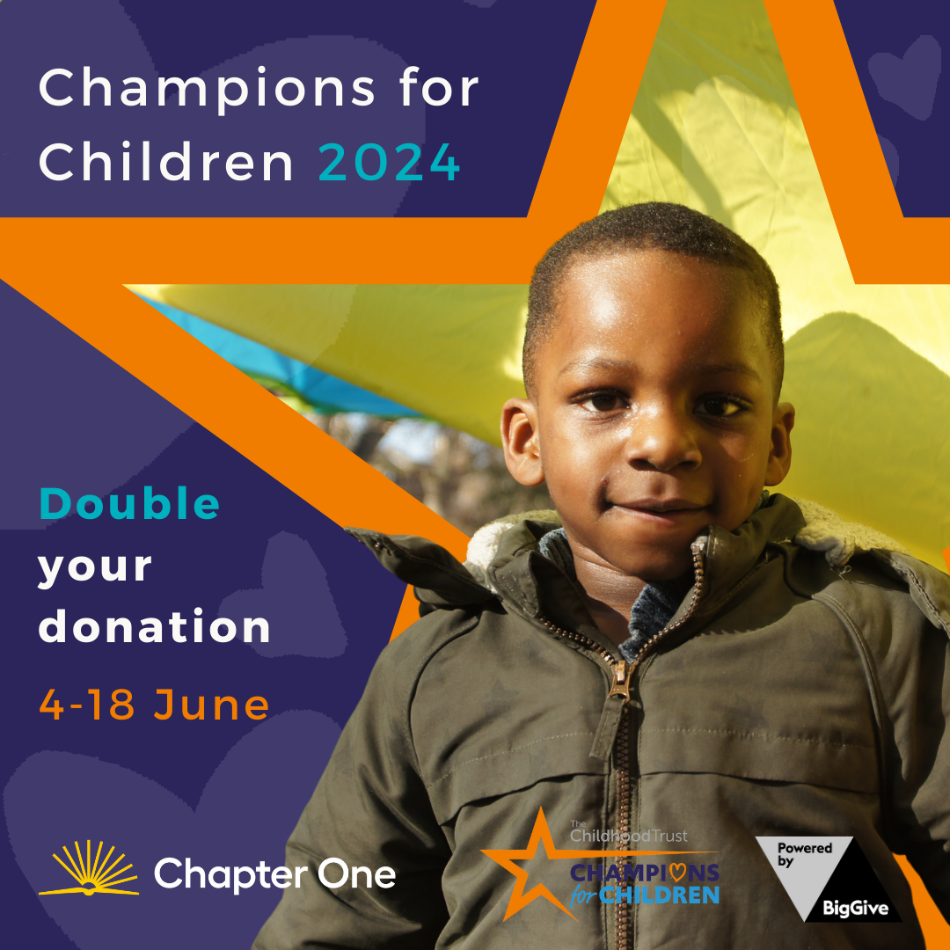

Chapter One is delighted to be taking part in [**The Childhood Trust’s Champions for Children** **matched giving campaign 2024**](https://donate.biggive.org/campaign/a056900002SEVi6AAH) to expand our reach to more children in London. Donations made to Chapter One during the campaign fortnight (4 to 18 June 2024) will be doubled!

**One donation, twice the impact.**

We have set ourselves the target of raising **£8,000** through our first Champions for Children campaign, which will be used to help **provide children in London with one-to-one reading sessions** during the 2024-25 school year.

Online donations made to Chapter One during the campaign fortnight up to a total value of **£4,000**, will be matched with £4,000 in pledged funds. Our pledge funders, who have agreed to support us on the basis of raising online donations are **The Childhood Trust**, **The Hollick Family Foundation** and **Liberty Global**.

Online donations to Chapter One will be made via the **Big Give online match funding platform**. All donations must be made by credit or debit card.

“We’re aiming to raise a total of £8,000 to support our work with struggling early readers in London. To unlock the £4,000 that we have in the matching pot from our generous pledgers, we need to raise £4,000 in online donations and are calling on our fantastic, engaged, Chapter One community to support this brilliant initiative and help transform the futures of more young children.”   
- **Emma Bell, CEO, Chapter One**

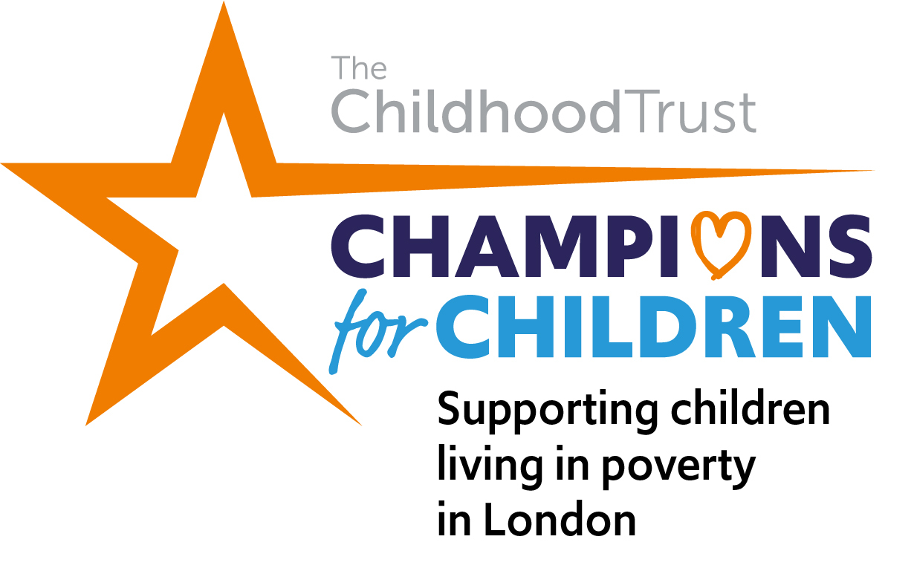

**How can you help the campaign during Volunteers’ Week and the following week?**

1. **Why not get together with your fellow Chapter One volunteers** and organise a fundraiser for the campaign?
2. **Visit our** [**Champions for Children campaign page**](https://donate.biggive.org/campaign/a056900002SEVi6AAH) **and make a donation** from midday on Tuesday 4 June to midday on Tuesday 18 June. Set a reminder so you remember not to miss your chance to double your donation!
3. **Help us to spread the word** and share information about the campaign with your networks. Keep an eye on our social media!

For further information, [read our FAQs](https://www.chapterone.org/uk/the-chapter-one-champions-for-children-campaign-june-2024?__geom=%E2%9C%AA) and/or please contact:  
**Lisa Barea**, Trusts and Foundations Fundraiser, [lisa.barea@chapterone.org](mailto:lisa.barea@chapterone.org)